# CS 255 Business Requirements Project One

Complete this template by replacing the bracketed text with the relevant information.

This template lays out all the different sections that you need to complete for Project One. Each section has guiding questions to prompt your thinking. These questions are meant to guide your initial responses to each area. You are encouraged to go beyond these questions using what you have learned in your readings. You will need to continually reference the interview transcript as you work to make sure that you are addressing your client’s needs. There is no required length for the final document. Instead, the goal is to complete each section based on your client’s needs.

**Tip:** You should respond in a bulleted list for each section. This will make your thoughts easier to reference when you move into the design phase for Project Two. One starter bullet has been provided for you in each section, but you will need to add more.

## System Components and Design

### Purpose

*What is the purpose of this project? Who is the client and what do they want their system to be able to do?*

* Build a web-based system that helps students pass DMV driving tests by providing online classes, practice exams, and on-the-road training reservations. Allow the owner to access business data from any device, with the ability to download reports for offline review (no offline editing).

### System Background

*What does DriverPass want the system to do? What is the problem they want to fix? What are the different components needed for this system?*

* Many students fail the DMV driving test; DriverPass wants an integrated learning and scheduling system that raises pass rates. Core capabilities: user accounts, online courses and practice tests, package selection, lesson reservations, driver/vehicle assignment, progress tracking, reporting, and role-based administration.

### Objectives and Goals

*What should this system be able to do when it is completed? What measurable tasks need to be included in the system design to achieve this?*

* Enable self-service scheduling and secretary-assisted booking. Track actions for accountability. Offer configurable lesson packages with the ability to disable a package. Present student progress and instructor notes clearly in the interface.

## Requirements

### Nonfunctional Requirements

*In this section, you will detail the different nonfunctional requirements for the DriverPass system. You will need to think about the different things that the system needs to function properly.*

#### Performance Requirements

*What environments (web-based, application, etc.) does this system need to run in? How fast should the system run? How often should the system be updated?*

* Cloud-based, browser application with quick response times. DMV content updates and data refresh without impacting live users

#### Platform Constraints

*What platforms (Windows, Unix, etc.) should the system run on? Does the back end require any tools, such as a database, to support this application?*

* Web application hosted in the cloud; no local installation required. Central database for users, drivers, vehicles, packages, reservations, lessons, tests, scores, and audit logs.

#### Accuracy and Precision

*How will you distinguish between different users?* *Is the input case-sensitive? When should the system inform the admin of a problem?*

* Role-based access control distinguishes user roles. Audit trail captures creator, last modifier, and timestamps.

#### Adaptability

*Can you make changes to the user (add/remove/modify) without changing code? How will the system adapt to platform updates? What type of access does the IT admin need?*

* Admins can enable or disable lesson packages without code changes. DMV integration supports automated updates and staff notifications.

#### Security

*What is required for the user to log in? How can you secure the connection or the data exchange between the client and the server? What should happen to the account if there is a “brute force” hacking attempt? What happens if the user forgets their password?*

* Secure password storage and password reset options. HTTPS for all connections. Payments through PCI-compliant gateway.

### Functional Requirements

*Using the information from the scenario, think about the different functions the system needs to provide. Each of your bullets should start with “The system shall . . .” For example, one functional requirement might be, “The system shall validate user credentials when logging in.”*

* The system shall allow students to create accounts, log in, and view online content and tests. The system shall allow students and staff to schedule, modify, and cancel lessons. The system shall manage lesson packages, track test attempts, record instructor notes, maintain audit logs, integrate with DMV systems, and allow export of data.

### User Interface

*What are the needs of the interface? Who are the different users for this interface? What will each user need to be able to do through the interface? How will the user interact with the interface (mobile, browser, etc.)?*

* Web-based interface accessible on desktop and mobile browsers. Student dashboard showing test progress and lessons. Scheduling interface with calendar and instructor selection. Admin console for user management and reporting.

### Assumptions

*What things were not specifically addressed in your design above? What assumptions are you making in your design about the users or the technology they have?*

* Reliable internet access. Students provide valid payment information. DMV provides structured update data.

### Limitations

*Any system you build will naturally have limitations. What limitations do you see in your system design? What limitations do you have as far as resources, time, budget, or technology?*

* No offline edits supported. Adding features requires development work. Mobile apps not in scope for first release.

### Gantt Chart

*Please include a screenshot of the GANTT chart that you created with Lucidchart. Be sure to check that it meets the plan described by the characters in the interview.*

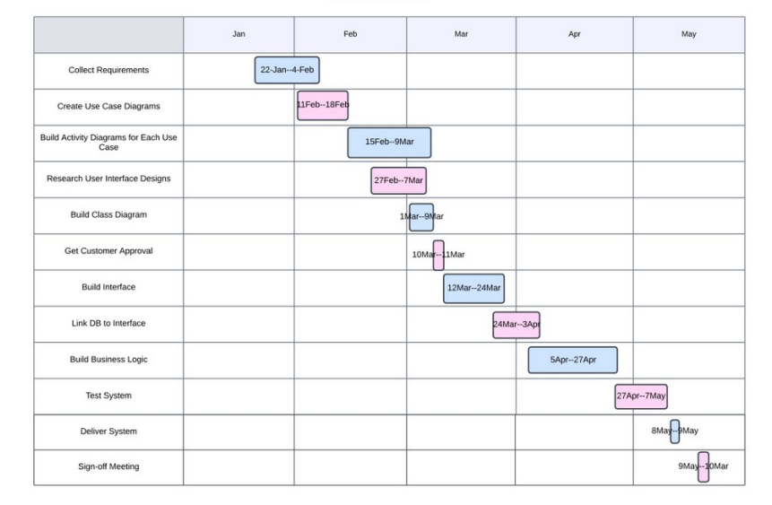

Loshin, P. (2019) How to encrypt and secure a website using HTTPS: TechTarget, Search Security. Available at: https://www.techtarget.com/searchsecurity/tip/How-to-encrypt-and-secure-a-websiteusing-HTTPS

Jatinsharmatu54et al. (2024) Backend development complete guide, GeeksforGeeks. Available at: https://www.geeksforgeeks.org/backend-development

Yasar, K. and Mullins, C.S. (2024) What is a database management system (DBMS)?: Definition from TechTarget, Search Data Management. Available at: https://www.techtarget.com/searchdatamanagement/definition/database-management-system

Noahsherry-SNHU/CS-255: SNHU CS255 work, GitHub. Available at: https://github.com/NoahSherry-SNHU/CS-255

Dana Thomas · et al. (2023) APIs in Motion: Keep your apis up-to-date, dzone.com. Available at: https://dzone.com/articles/apis-in-motion-keep-your-apis-up-to-date